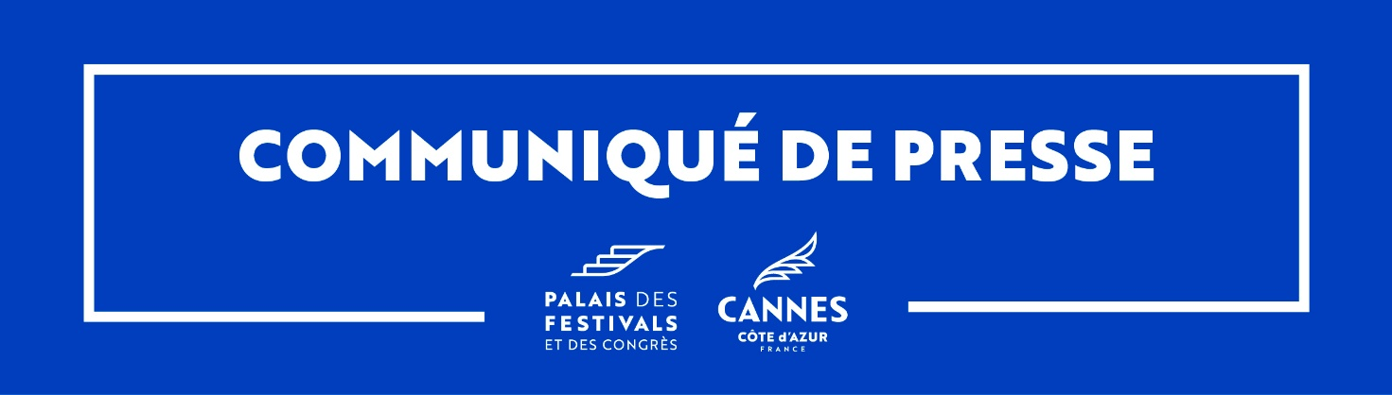
Press Release
Cannes, 16 June 2025

Cannes, a crypto-friendly destination
More than 50 businesses in Cannes already accept
cryptocurrency payments

As part of a pioneering local Web3 strategy, the town of Cannes and its Palais des Festivals et des Congrès are continuing their drive for innovation: after being the first convention centre in France to accept cryptocurrency payments, Cannes has now become the benchmark crypto-friendly French destination, by encouraging local businesses to offer this payment option.
In the run up to the Cannes Lions International Festival of Creativity in June and the Ethereum Community Conference (EthCC), which will be held in Cannes from 30 June to 3 July, some fifty Cannes-based companies (beach-related businesses, restaurants, hotels, retailers and other businesses) are now accepting cryptocurrency payments. This initiative is a concrete way to modernise the customer experience, enhance the destination's economic appeal and boost business revenues in readiness for hosting major international events in the Web3 ecosystem.

"Cannes has always been able to adapt to change to remain a welcoming, innovative and future-focused town. This is not about promoting or judging cryptocurrencies, but rather about enabling interested Cannes companies to attract an international clientèle familiar with such uses. In some countries, these payment methods are already widely accepted; we therefore need to get up to speed, to ensure that Cannes does not deprive itself of an additional economic lever. By training, informing and supporting businesses in this transition, we can offer them new sales opportunities. As part of our Web3 strategy and in the run-up to EthCC - Europe's biggest blockchain event, we are positioning Cannes as a pioneer of digital, connected hospitality.”
David Lisnard, Mayor of Cannes

"As the first convention centre in France to accept cryptocurrency payments, we are continuing our commitment to innovation to fulfil our raison d'être: Welcoming the world sustainably. This approach is part of our drive to expand our range of services to meet the expectations of visitors, delegates and professionals from fast-changing ecosystems. By offering his new payment solution, it will be easier to host international customers, while supporting Cannes' businesses as they adopt new digital practices.”
Jean-Michel Arnaud, Chairman of the Palais des Festivals et des Congrès de Cannes

A kit to identify businesses that accept cryptocurrency payments
Participating companies have been given a ‘Cannes Crypto-Friendly’ communication kit to raise their profile. The kit includes an official logo, window sticker, publicity materials for use on social media, etc. All these materials are designed to clearly show that cryptocurrencies are accepted, at the same time as improving customer experience.

A specific web page and enhanced visibility
An interactive map along with a list of participating companies can be found on the Tourist Office's website: https://en.cannes-france.com/stay-in-cannes/cannes-crypto-friendly/
This link is being shared with all interested event organisers, including the EthCC, to inform the 10,000 business visitors expected in Cannes at the end of June 2025.

Raising awareness and providing support: preparing for EthCC 2025!
In the run-up to this major event, Cannes Town Council and the Palais des Festivals et des Congrès have set up a support programme for local businesses; This included two Digital Bootcamps held on 4 February and 3 April 2025, on the theme of ‘Deciphering cryptocurrency’.
These sessions provided an opportunity to present the strategic, tax and legal issues associated with the new payment methods, propose practical solutions and share feedback.
As a result, more than 50 tourism professionals in Cannes have already taken the plunge and accept cryptocurrency payments. The engagement of local businesses is high in the run-up to EthCC 2025.

